The Marine Iguana of the Galapagos Islands
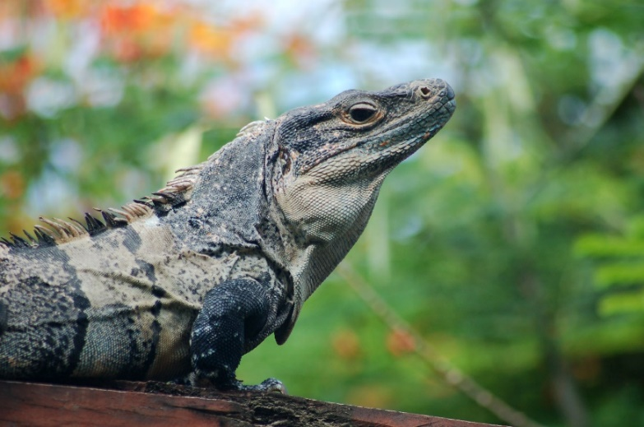
The ancestor of the marine iguana would have probably looked similar to this species of land iguana that is found in Central and South America.
Their habitat is full of lush green vegetation that thrives in the warm, humid climate.
Being herbivores, they have plenty of tasty food to choose from and can easily find shelter from the hot sun and predators.
Travelling across the Pacific Ocean on rafts of vegetation washed into rivers after violent tropical storms, the ancestor of the marine iguanas landed on the shores of the Galapagos. Black volcanic rocks lined the coast, little vegetation grew and there was no fresh water.
The animals that inhabited this new environment were also different. There are fewer species of reptiles and invertebrates and no amphibians. In place of the colourful tropical birds, finches are more common, although some of the coastal birds they now shared their home with would be familiar. The only mammals are those that were introduced by humans. Some became predators: a new threat that the iguanas faced.
After their journey across the Pacific Ocean, the first iguanas that colonised the islands must have been very hungry. There was no lush vegetation lining the shores on which they could feed, only prickly cactus trees and algae that clung to the rocks where sally lightfoot crabs could be seen grazing.
Some fed on the cactus, others had no alternative but to find other sources of food, and so over time they became specialist grazers on the red and green algae. Not only did they adapt to graze on algae that grew on the shore, some bigger adult iguanas learned how to dive and swim down to rocks on the sea bed to feed.
So over a long, long time some of the land iguanas that originally journeyed across the Pacific changed and adapted to become iguanas that lived on the rocky shorelines and dived in the sea. The only sea-going lizards in the world.
They became the Marine Iguanas of the Galapagos. They can be seen nowhere else on Earth.

The ability to adapt their diet was not the only adaptation the iguanas made. With a learning partner have a look at the following images and questions to investigate the mysteries of the marine iguana.
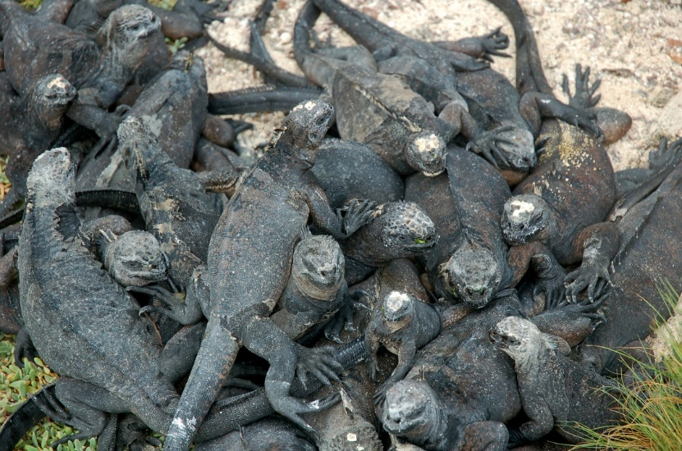

Iguanas are cold blooded reptiles. These juveniles are small and are living in a colony (group). Why do you think they are piled on top of each other?

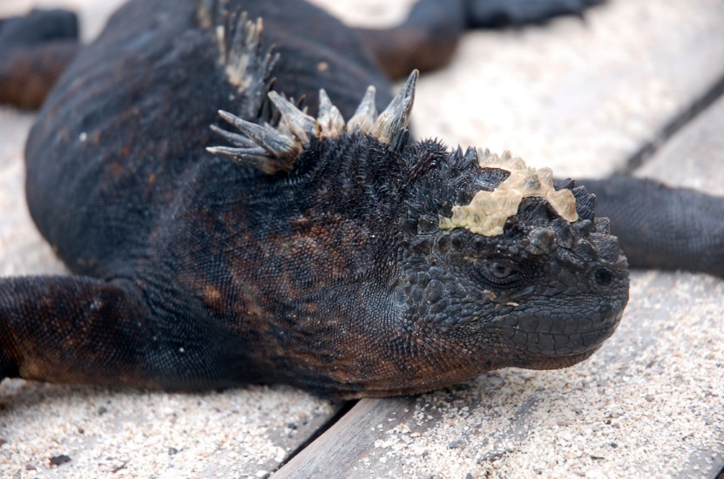

When iguanas spend time in the sea foraging for food, their bodies take in excess (too much) salt from the algae they eat. They sneeze the salt out through special glands in their nose. Can you see the salt on this iguana?

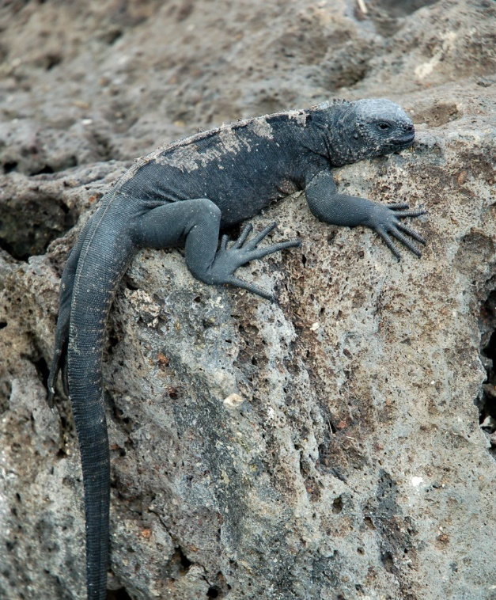

One of the iguanas natural predators is the Galápagos hawk (Gavilán de Galápagos). How does this iguana help prevent itself from being seen by its predator?
Why do you think the iguanas sometimes flatten their bodies when they are out of the water?

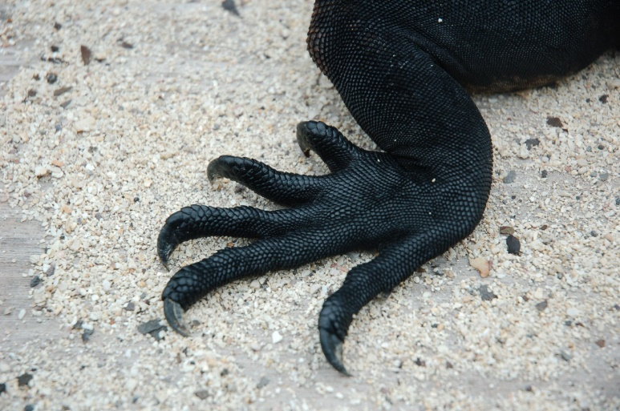

The marine iguana is the only species in the world that feeds in the ocean. They graze on algae that grows on rocks. How do you think their claws help them do this?

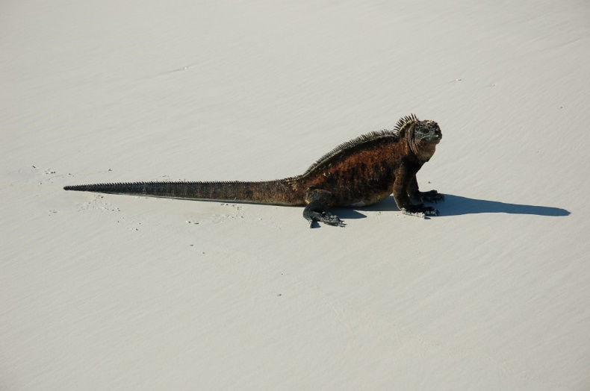

Iguanas can swim in the sea and can dive up to ten metres. Look at its tail, how do you think it helps it swim?

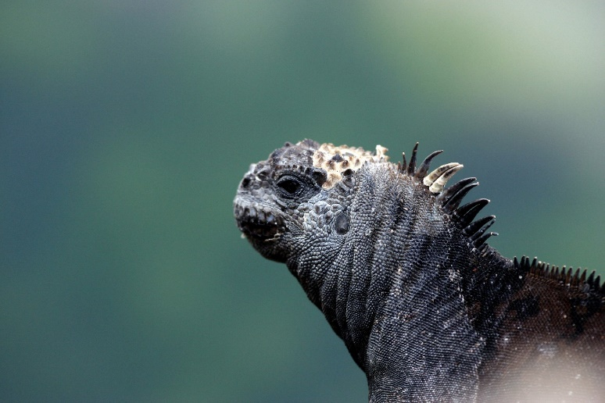

Marine iguanas have more of a flattened area around their nose and mouth than their ancestors and the land iguanas of the islands. Why do you think this is? Clue – diet!

